Session 2025-2026
Mission: To establish learning ambience for ushering in computer engineering professionals in core and
multidisciplinary area by developing Problem-solving skills through emerging technologies.
Vision: To be a well-known centre for pursuing computer
education through innovative pedagogy, value-based education and industry collaboration
Program Educational Objectives of the program (PEO): (broad statements that describe the professional and career accomplishments)
PEO1 | Preparation | P: Preparation | Pep-CL abbreviation pronounce as Pep-si-lL easy to recall
PEO2 | Core Competence | E: Environment (Learning Environment)
PEO3 | Breadth | P: Professionalism
PEO4 | Professionalism | C: Core Competence
PEO5 | Learning Environment | L: Breadth (Learning in diverse areas)

Program Outcomes (PO): (statements that describe what a student should be able to do and know by the end of a program)

Keywords of POs:
Engineering knowledge, Problem analysis, Design/development of solutions, Conduct Investigations of Complex Problems, Engineering Tool Usage, The Engineer and The World, Ethics, Individual and Collaborative Team work, Communication, Project Management and Finance, Life-Long Learning
PSO Keywords: Cutting edge technologies, Research
“I am an engineer, and I know how to apply engineering knowledge to investigate, analyse and design solutions to complex problems using tools for entire world following all ethics in a collaborative way with proper management skills throughout my life.” to contribute to the development of cutting-edge technologies and Research.

Integrity: I will adhere to the Laboratory Code of Conduct and ethics in its entirety.

Name and Signature of Student and Date
(Signature and Date in Handwritten)
Disha Angalwar
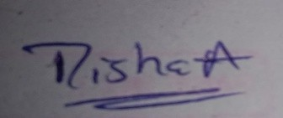

Session | 2025-26 (EVEN) | Course Name | JAVA FSD Lab
Semester | 4 | Course Code | 23ADS1407
Roll No | 4 | Name of Student | Disha Angalwar

Practical Number | 08
Course Outcome | - Analyze Java programs to implement exception handling and file handling operations.  2.Design and develop a mini project using Java that integrates object-oriented programming concepts, file handling, and database connectivity.
Aim | WAP to demonstrate concept of file handling
Problem Definition | Write a Java program to demonstrate file handling and exception handling by reading data from a text file.  Create a file named sample.txt and read its contents line by line using a Scanner object. Display each line on the console. Handle the error that occurs if the file is not found using a try-catch block with FileNotFoundException..
Theory  (100 words) | File handling in Java allows programs to read from and write to files stored on the system. It is performed using classes from the java.io and java.util packages, such as File and Scanner. In this program, a file is read line by line using a Scanner object. Exception handling is used to manage errors like FileNotFoundException when the specified file does not exist. The try-catch block ensures that the program does not crash and displays an appropriate message. This concept improves reliability and enables efficient data processing from external files.

Procedure and Execution | Algorithm:  - Start the program.  - Create a class ReadFileExample.  - Create a File object for "sample.txt".  - Use a try block to open the file using Scanner.  - Check if the file has next line using hasNextLine().  - Read each line using nextLine().  - Display the line on the console.  - Repeat until all lines are read.  - If file is not found, handle using catch block.  - Display error message.  - Stop the program.  Code:  import java.io.File;  import java.io.FileNotFoundException;  import java.util.Scanner;  public class ReadFileExample {  public static void main(String[] args) {  // Specify the file to be read  File file = new File(&quot;sample.txt&quot;);  try (Scanner scanner = new Scanner(file)) {  // Read and print each line from the file  while (scanner.hasNextLine()) {  String line = scanner.nextLine();  System.out.println(line);  }  } catch (FileNotFoundException e) {  System.err.println(&quot;File not found: &quot; + e.getMessage());  }  }  }
(100 Words)
 | Output:
 | 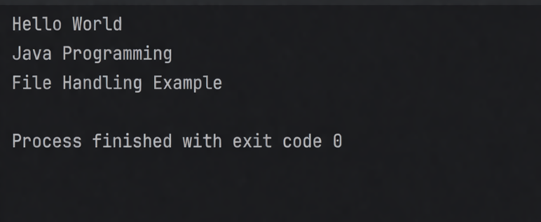
Output Analysis | The program attempts to read data from a file named sample.txt.  If the file exists, it reads and displays each line sequentially using a loop.  The use of Scanner ensures efficient line-by-line reading.  If the file is not found, a FileNotFoundException is thrown.  The catch block handles the error and displays an appropriate message.  The program executes smoothly without crashing, showing proper exception handling and file processing..

Link of student Github profile where  lab assignment has been uploaded | https://github.com/dishaangalwar84/JavaFSD
Conclusion | In this practical, we studied the concept of file handling and exception handling in Java. We learned how to read data from a text file using the File and Scanner classes. The program demonstrated how to process file data efficiently by reading it line by line. We also understood the importance of handling runtime errors using try-catch blocks, specifically FileNotFoundException when the file is not available. This practical helped in improving program reliability, ensuring smooth execution, and preventing unexpected crashes. Overall, it enhanced our understanding of working with external files and managing exceptions effectively in Java.
Plag Report (Similarity index < 12%) | 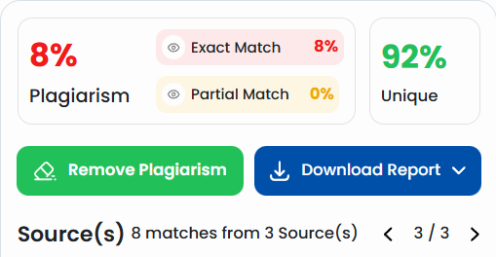
Date | 24 Mar 2026
Faculty signed observation page.

